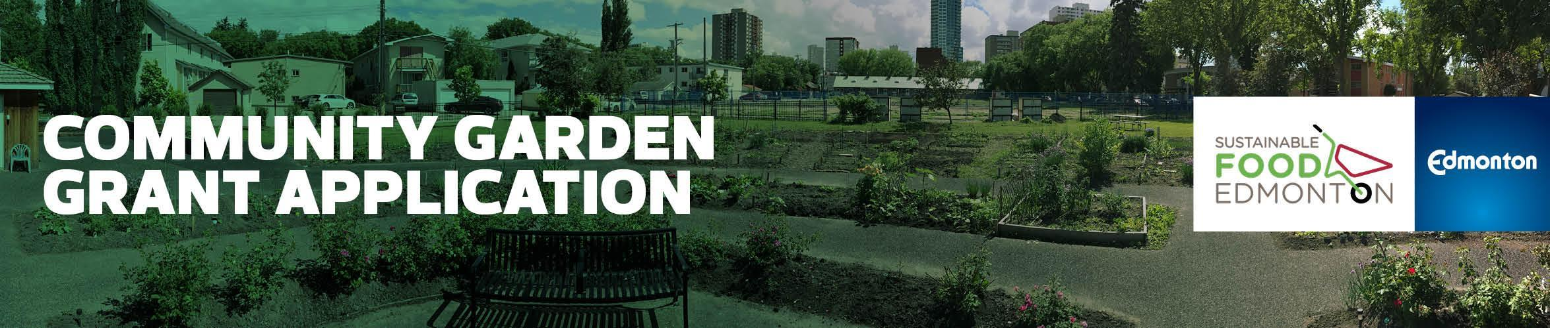

EMERGENCY Community Garden Grant 2019

Intake opens on Feb 28, 2019, and is ongoing for the year provided funds remain. Please check with the Community Garden Facilitator before applying.

Funding is provided to SFE from the City of Edmonton

Garden Name
Garden Address & Neighborhood
Submission Date
Amount Requested
Contact Name
Contact Address
Phone
Email
Secondary Contact Name

Phone
Email

SFE Associate Community Garden Member since: ______________________________

Cheque payable to (must not be an individual): ________________________________

Edmonton Community Services Representative (NRC/SW):

Phone
Email

Have you included the following attachments?
- Site map
- 1 Letter of Support
- Land Use Agreement (signed copy)*
- Budget
- Photos
- Quotes from two sources

*What type of Land Use Agreement depends on what type of land your garden is on:

- If on City land, please provide the Memorandum of Understanding

- If on private land, please provide the Land Use Agreement

- If on school land, please provide a Letter of Support from the School Board or school administration

- If on community league land, please provide the Land Use Agreement

Project Summary

- Briefly describe your project and why your group requires emergency funding.

b) Describe how your group will mitigate future risks to your garden assets and projects.

c) Of the 2 quotes, which one are you going with and why?

d) What will be the impacts if your group is not awarded the emergency grant?

Community Garden Committee Members:

Please list all of your community garden committee members

Role | Name:
 | 1.
 | 2.
 | 3.
 | 4.
 | 5.

Project Schedule (Key Milestones)

List the key activities for each repair/replacement activity along with the dates.

Completion Date | Start Date | Deliverable/Activity

Additional Comments:

Budget:

Please download and complete the budget template from the SFE website.

Please email your completed application, along with required attachments to
Junetta Jamerson, Community Garden Facilitator, at: cgfacilitator@sustainablefoodedmonton.org

