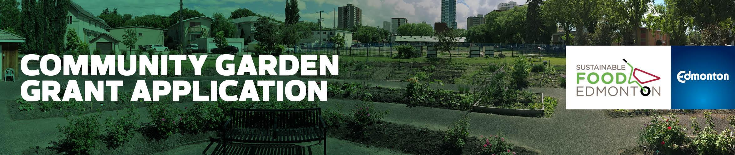

EXPANSION or RENOVATION Community Garden Grant 2018

First Intake Deadline: February 28, 2018
Second Intake Deadline: May 31, 2018

Funding is provided to SFE from the City of Edmonton

Garden Group Name:
Submission Date
Amount Requested
Contact Name
Mailing Address
Phone
Email
*Please be available to answer questions, or provide clarification from the Community Garden Grant Committee via phone on March 13, 6-9 PM.
Secondary Contact Name

Phone
Email

Date Community Garden Established (1st Growing Season): ________________________

SFE Associate Community Garden Member since: ______________________________

Cheque payable to (must not be an individual): ________________________________

Edmonton Community Services Representative (NRC/SW):

Phone
Email

Have you included the following seven attachments?
- Work/Site plan with measurements
- Terms of Reference
- Membership Contract
- Letters of Support: confirmation of financial, donation, or community support from other groups, agencies, or grants
- Partner & Parks Agreement or Land Use Agreement (signed copy)*
- Budget
- Photos

*What type of Land Use Agreement depends on what type of land your garden is on:

· If on City land, please provide the Memorandum of Understanding

· If on private land, please provide the Land Use Agreement

· If on school land, please provide a Letter of Support from the School Board or school administration

· If on community league land, please provide the Land Use Agreement

Project Summary

Please describe: where your garden is located, when it was established, how the site is used and by who, what kind of gardening takes place, number of plots and number of gardeners

Project Rationale

Please describe: why your garden needs to expand, or what renovations are necessary

Garden Project Plan

The following things are necessary for a successful garden. How are they affecting, or be an updated part of, your community garden?

Overall Size
Plots (quantity, type and dimensions)
Water (where is the water coming from)
Garbage Collection (# of garbage cans, who is responsible to empty them)
Composter (size, who will maintain it, any rules e.g. no weeds)
Signage (let your neighborhood know about your garden)
Storage (of tools, supplies. If it’s a shed, include dimensions)
Vandalism Deterrence (fence, lights, programs)
Washroom Availability
Sun Exposure (natural light, south facing, large buildings nearby)
Grading Drainage (is site flat, hills, impact of garden on drainage)
Soil Quality (e.g. importing high grade soil, soil testing used)
Surrounding Land Uses (and the potential effect on your garden)
Fertilizers/Pesticides (your garden’s policy)
Tree Impact (effort to protect trees)
Accessibility (for those with disabilities, walkable distance)

Additional Comments

Project Group Dynamics

Explain how you operate as a group, your strategies for success, and future thinking ie.
how you organized: roles/responsibilities, independent/community league; strategies
for decision making: consensus/majority rules, steps for conflict resolution; annual
meeting schedule (list of when they are to take place): spring set up, fall clean up,
special committees, recruiting, gardener sign up, Terms of Reference, annual review,
etc. Terms of Reference may be sent as a separate attachment.

Community Garden Committee Members:

Please list all of your community garden committee members and their contact information.

Name | Role | Contact Info
1.
2.
3.
4.
5.
6.
7.
8.
9.
10.
11.
12.

Project Schedule (Key Milestones)

List the key activities for each project phase along with the dates.

Deliverable/Activity | Start Date | End Date
Concept Phase
Design Phase
Build Phase
Operate Phase

Budget

Please download the budget template on the SFE website. Remember, your group is expected to find additional funds to a minimum of 30% of the total grant requested.

This may include, but is not limited to, documented in-kind volunteer hours.

Please email your completed application, along with required attachments to
Junetta Jamerson, Community Garden Facilitator, at: cgfacilitator@sustainablefoodedmonton.org

