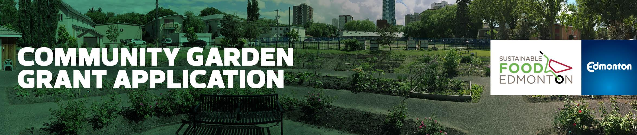

NEW Community Garden Grant Application 2019

First Intake Deadline: February 28, 2019
Second Intake Deadline: May 31, 2019

Funding is provided to SFE from the City of Edmonton

Garden Group Name:
Submission Date
Amount Requested
Contact Name
Mailing Address
Phone
Email
*Intake 1: Please be available to answer questions, or provide clarification from the Community Garden Grant Committee via phone on March 19, 6-9 PM
Secondary Contact Name

Phone
Email

SFE Associate Community Garden Member since: ______________________________

Cheque payable to (must not be an individual): ________________________________

Edmonton Community Services Representative (NRC/SW):

Phone
Email

Have you included the following seven attachments?
- Work/Site plan: show plots, sizes, materials – all elements you must build and area you will use
- Terms of Reference for the garden group
- Membership Contract
- Letters of Support: confirmation of financial, donation, or community support from other groups, agencies, or grants
- Partner & Parks Agreement or Land Use Agreement (signed copy)*
- Budget
- Photos: showing the context and contours of the site

*What type of Land Use Agreement depends on what type of land your garden is on:

· If on City land, please provide the Concept Phase Approval Letter or Memorandum of Understanding

· If on private land, please provide the Land Use Agreement

· If on school land, please provide a Letter of Support from the School Board or school administration

· If on community league land, please provide the Land Use Agreement

Project Summary

Please describe: a) what kind of gardening will take place, b) how the garden group come together and why, c) other supporting partners, d) how long you have been working on the project, e) where the garden is located, f) how the site will be used and by who, g) how many gardeners will be accommodated, h) the number of plots and i) the main infrastructure required (raised beds, bins, signage, shed, tables, etc.)

Project Rationale

How does this garden meet the needs of your neighborhood? What’s unique about your community? What methods did you use to build interest and buy-in? Include information gathered from the Needs Assessment used.

Garden Project Plan

The following things are necessary for a successful garden. Describe how they will be affect, or be a part of, your community garden.

Overall Size
Plots (quantity, type and dimensions)
Water (where is the water coming from)
Garbage Collection (# of garbage cans, who is responsible to empty them)
Composter (size, who will maintain it, any rules e.g. no weeds)
Signage (let your neighborhood know about your garden)
Storage (of tools, supplies. If it’s a shed, include dimensions)
Vandalism Deterrence (fence, lights, programs)
Washroom Availability
Sun Exposure (natural light, south facing, large buildings nearby)
Grading Drainage (is site flat, hills, impact of garden on drainage)
Soil Quality (e.g. importing high grade soil, soil testing used)
Surrounding Land Uses (and the potential effect on your garden)
Fertilizers/Pesticides (your garden’s policy)
Tree Impact (effort to protect trees)
Accessibility (for those with disabilities, walkable distance)

Additional Comments

Project Group Dynamics

Explain how you operate as a group, your strategies for success, and future thinking. This includes how you organize: roles/responsibilities, independent/community league, strategies for decision making (consensus/majority rules, steps for conflict resolution) annual meeting schedule (list of when they are to take place), spring set up, fall clean up,
special committees, recruiting, gardener sign up, annual review, etc.

Community Garden Committee Members:

Please list all of your community garden committee members and their contact information.

Name | Role | Contact Info
1.
2.
3.
4.
5.
6.
7.
8.
9.
10.
11.
12.

Project Schedule (Key Milestones)

List the key activities for each project phase along with the dates.

Deliverable/Activity | Start Date | End Date
Concept Phase
Design Phase
Build Phase
Operate Phase

Budget

Please download the budget template on the SFE website. Remember, your group is expected to find additional funds to a minimum of 30% of the total grant requested.

This may include, but is not limited to, documented in-kind volunteer hours.

Please email your completed application, along with required attachments to:
Junetta Jamerson, Community Garden Facilitator at: cgfacilitator@sustainablefoodedmonton.org

