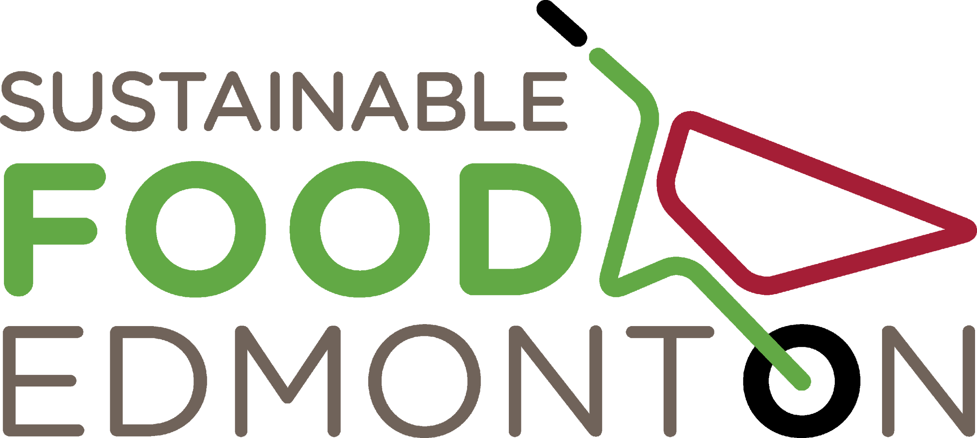

Out of Town
Community Garden Grant Guidelines
2019

Thanks to support from Pembina Pipeline, Sustainable Food Edmonton (SFE) is making up to $5000 available to community garden groups outside of Edmonton Corporate City Limits. The grant is to support the costs of goods and services needed to start, expand or repair a garden site.

Applicants may apply at either intake: February 28 or May 31, 2019. Unsuccessful applicants may apply again in the same year, pending available funds.

According to the latest Edmonton Census Metropolitan Region (CMR), the following communities are eligible to apply:

- Four cities: Fort Saskatchewan, Leduc, St. Albert, and Spruce Grove
- One specialized municipality (Strathcona County, which includes the Sherwood Park urban service area
- Three municipal districts: Leduc County Parkland County, and Sturgeon County
- Eleven towns: Beaumont, Bon Accord, Bruderheim, Calmar, Devon, Gibbons, Legal, Morinville, Red Water, Thorsby, Stony Plain
- Three villages: Spring Lake, Wabamun, and Warburg
- Eight summer villages: Betula Beach, Golden Days, Itaska Beach, Kapasiwin, Lakeview, Point Alison, Seba Beach, and Sundance Beach
- Four Indigenous reserves for three First Nations: Alexander 134 of the Alexander First Nation, Stony Plain 135 of the Enoch Cree Nation, and Wabamun 133A and 133B of the Paul First Nation

Applicants are typically self-governing groups of volunteers committed to oversee the garden’s development and administration.

To increase the likelihood of a successful application, it is recommended that groups work with the SFE Community Garden Facilitator and to build an effective Terms of Reference, Work Plan and Budget.

Your city, town or county may also be able to support parts of your application.

The grant fund is to support:

1. The establishment of a new community garden
2. A significant expansion or renovation of an existing site
3. Emergency needs or repairs
4. A small-scale pilot project

Deadlines: February 28 and May 31, 2018.

Emergency grants have an ongoing intake, pending available funds. Check with the Community Garden Facilitator before submitting an application.

Amounts:

- $5000 (max) for new garden projects, expansion or renovation projects
- $1000 (max) for pilot projects or emergency needs

A community garden group will normally be eligible for a grant once every 5 years.

Exceptions are:

- Pilot project grant recipients are eligible to apply for a new community garden grant without having to wait 5 years.
- Emergency grants are open to all garden groups, even those who have received a grant in the past 5 years. They are intended to support gardens through unforeseen events such as theft, vandalism, environmental damage, etc. The grant is not intended to cover what can be mitigated through proper planning and sound operational procedures.

Eligibility Checklist:

o Your garden is open to the public
o Your garden is outside Edmonton Corporate City limits
o No chemicals pesticides will be used
o You have a Garden Committee of 9-12 eager volunteers. Pilot projects may have a smaller committee of 4-7 volunteers.
o You have built awareness and support within your community
o You have determined a location and have a signed land use agreement
o You have determined a realistic budget based on what your community needs

Requirements:

1. Funds must go to a community garden organization, not an individual.
2. The organization must be an associate member of Sustainable Food
Edmonton (SFE). There is an annual fee of $10 for each community garden
organization. Contact Community Garden Facilitator to apply.
3. Funds must go towards goods and services needed to establish, significantly
expand or restore a community garden site outside the City of Edmonton.
4. An appropriate land use agreement must be in progress and will vary dependent
on the type of land (city, town, municipality or private).
5. A final report on activities, garden and participation statistics along with expenditures are required. Report templates will be made available to successful applicants.

Eligible Expenses & Budget:

The budget should include only the goods (e.g. soil, equipment, lumber for raised beds, etc.) and services (e.g. trucking, bobcat for site preparation, etc.) required to establish the community garden site.

Donated goods and services should be identified as in-kind contributions in the budget.

Not Eligible: Ongoing maintenance and operational expenses (e.g. annual water costs, winterizing water lines, annual tilling)

Community groups are encouraged to seek additional funding and resources from other sources to meet project costs. Your group is expected to find additional funds to a minimum of 30% of the total grant requested. This may include, but is not limited to, documented in-kind volunteer hours.

Exception: pilot project and emergency grant applicants are not required to have a minimum of 30% of expenses covered from other sources.

Funds for all grants will be distributed in a single payment, made available within 10-12 weeks of the application deadline.

Please retain all receipts and invoices. We understand original copies are sometimes required by other funders. In this case, scans are acceptable.

Assessment:

A grant selection committee, comprised of representatives from the SFE Board and members of the public, will review all applications. Committee members may serve at both grant intakes. Their recommendations will be forwarded to SFE. SFE will notify successful applications approximately 3 weeks from the application deadline.

Preference will be given to community garden organizations that demonstrate in the application and budget how they will:

1. Include individuals from their community regardless of ability and background
to participate in the community garden.
2. Communicate openly and clearly with gardeners.
3. Work with gardeners to plan, make decisions and resolve issues concerning
the community garden.
4. Maintain community garden site in accordance with the terms of the land
access arrangements.
5. Prove to meet the criteria of a priority neighbourhood:
- High social vulnerability index
- Med-high population density
- Med-high percentage of recent immigrants
- No other nearby community gardens with waitlists under 2 seasons
Other non quantifiable characteristics:
- Identified by NRC or by group itself as lower capacity: previously failed garden project, strong reliance on partner organizations for translation, admin/written skills and/or governance support
- Community league or partner orgs not able to support garden project financially: The garden group is not able to show that 30% of the funds are coming from another source (partner, grant, community league, etc).
​
6. Obtain additional required funds and/or resources as needed for garden startup
and maintenance.
7. Review and update community garden access/land lease arrangements as
required.
8. Complete SFE’s annual survey
9. Attend the Budget Workshop. Registration info will be shared via our social media, newsletter and website.

Application Format and Process:

Applicants must submit a complete application on or before the deadlines of February 28, or May 31, 2018.

Application forms are available to download from the SFE website.

Completed applications and attachments will be emailed to:
cgfacilitator@sustainablefoodedmonton.org

Paper applications will be accepted when there are barriers to Internet use. Please notify the Community Garden Facilitator you are submitting a paper application as early as possible.

For more information, please contact Junetta, the Community Garden Facilitator,
at 780-708-5223 or cgfacilitator@sustainablefoodedmonton.org

